Inventory ageing (with loc)

Current report:
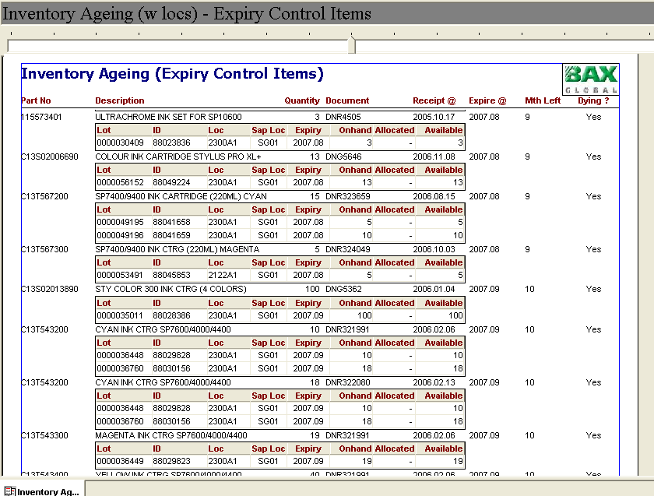
Duplicate lot detail for SKU C13T543200

To modify report to group by SKU only, Document # is not required.
Receipt Date, exipiry date, mth left and Dying? Information to move into lot detail lines.

